|  |  |  |  |  |  |
| --- | --- | --- | --- | --- | --- |
| Date | 6-Dec-22 | | | Tester Name | Mayuri Patel |
| Environment | Penfax - Test | | | Login used |  |
| Operating System | Select OS | Version: | Update: | | |
| Software Used | Select Software | Version: | Update: | | |
| Select Software | Version: | Update: | | |
| Release version | 22.4.1 | | | | |
| Title |  | | | | |
| Test Type | Regression | | | | |
| Test Scenario | Process a lump sum of 100% of the balance of the VPB | | | | |
|  |  | | | | |
| Expected Results |  | | | | |
| Pass/Fail | Pass | | | JIRA# | N/A |

Describe your steps with screenshots:

Search a member to process 100% lump sum VPB

Open that member Profile

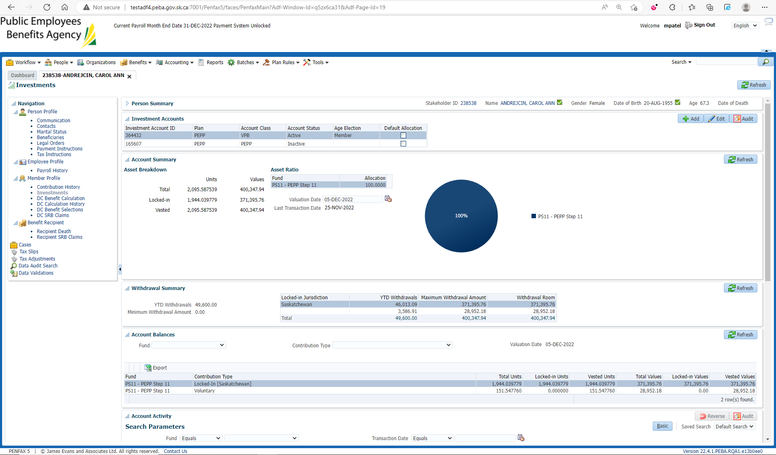

Go to DC Benefit Selection and Next

Add all Allocations and Save

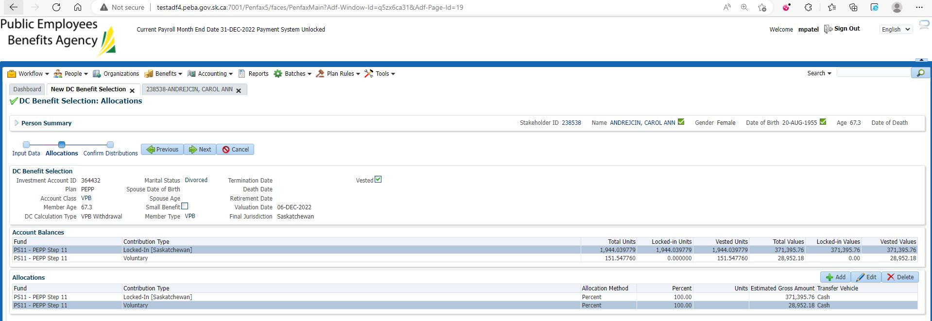

Submit for Approval and Approve it

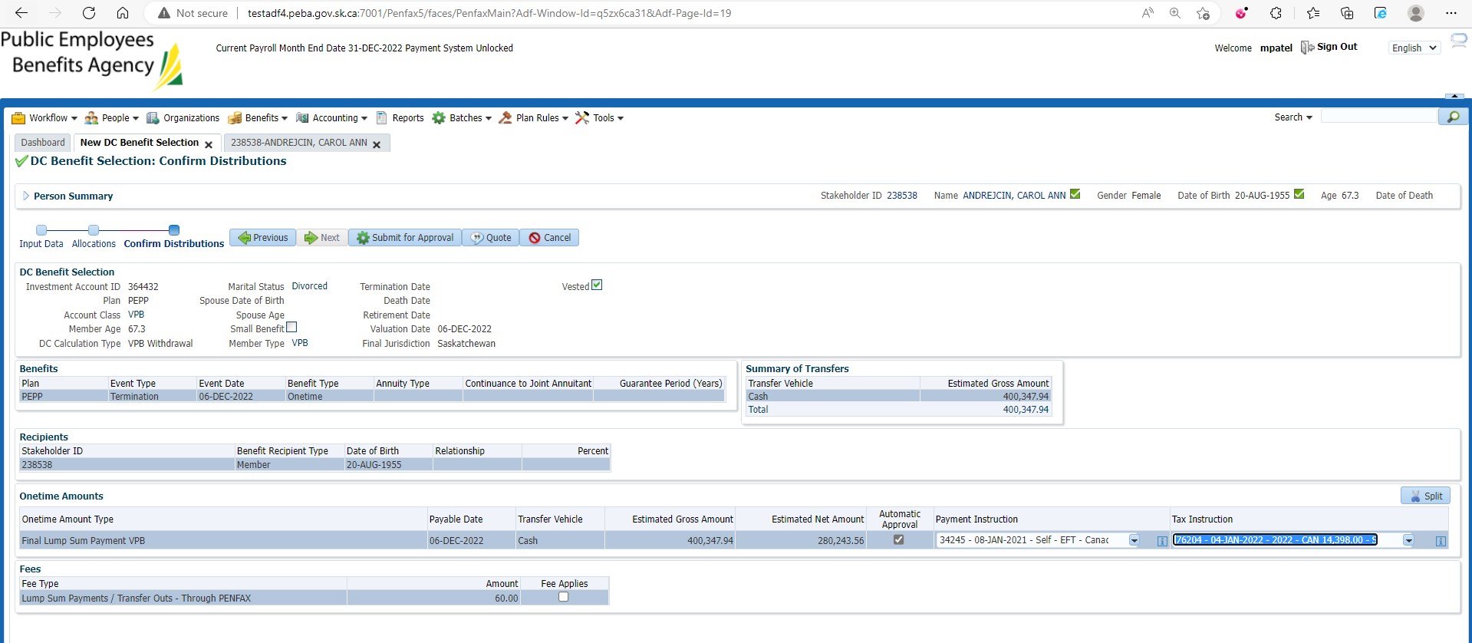

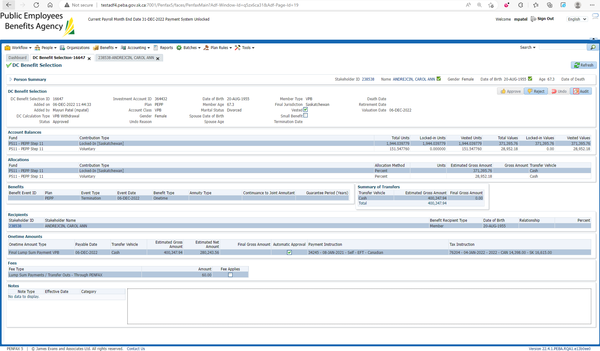

After Overnight PIT Batch

Open that member profile

Under Investments

Select VPB Account and make sure it is inactive

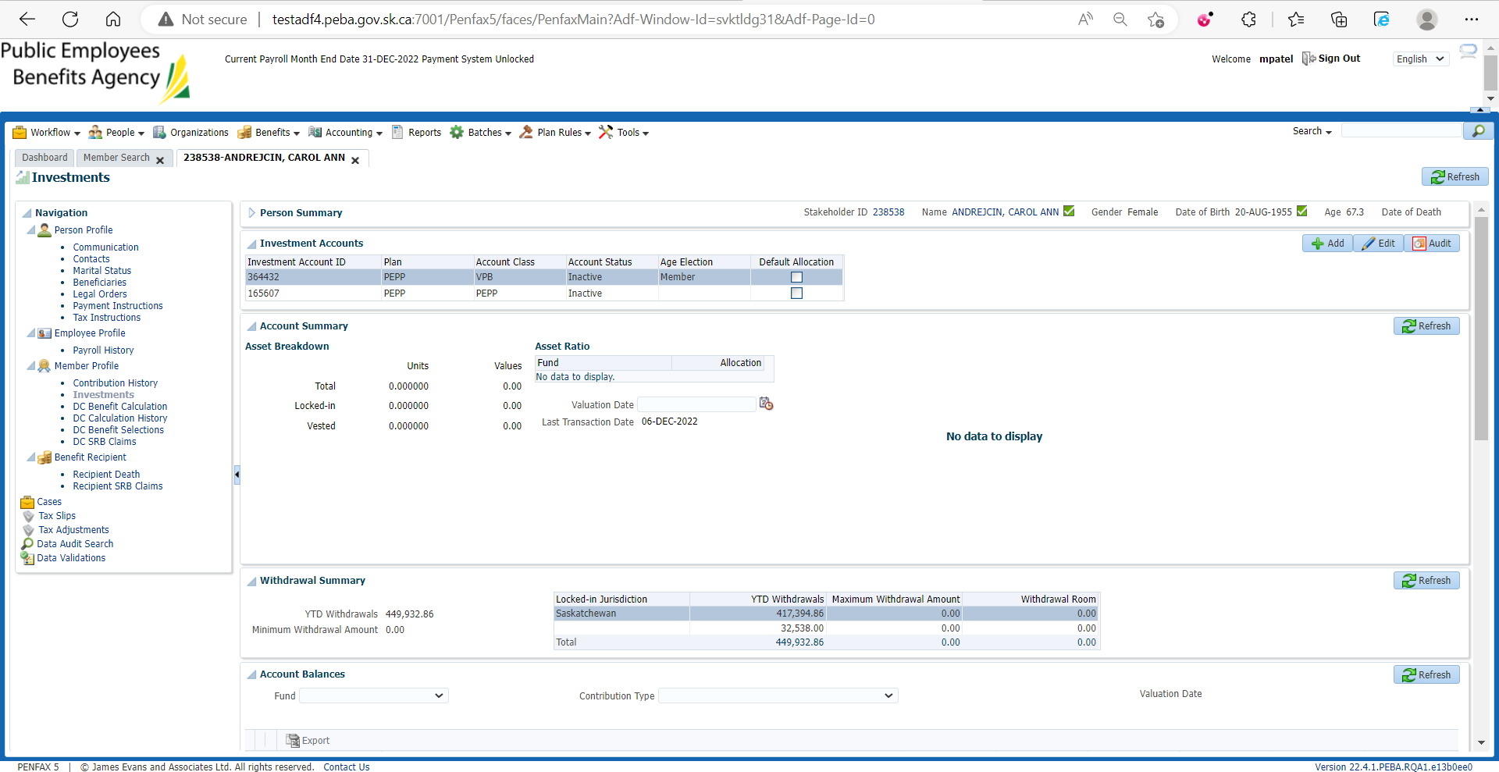

Under Benefit Recipient🡪 onetime Amount tab

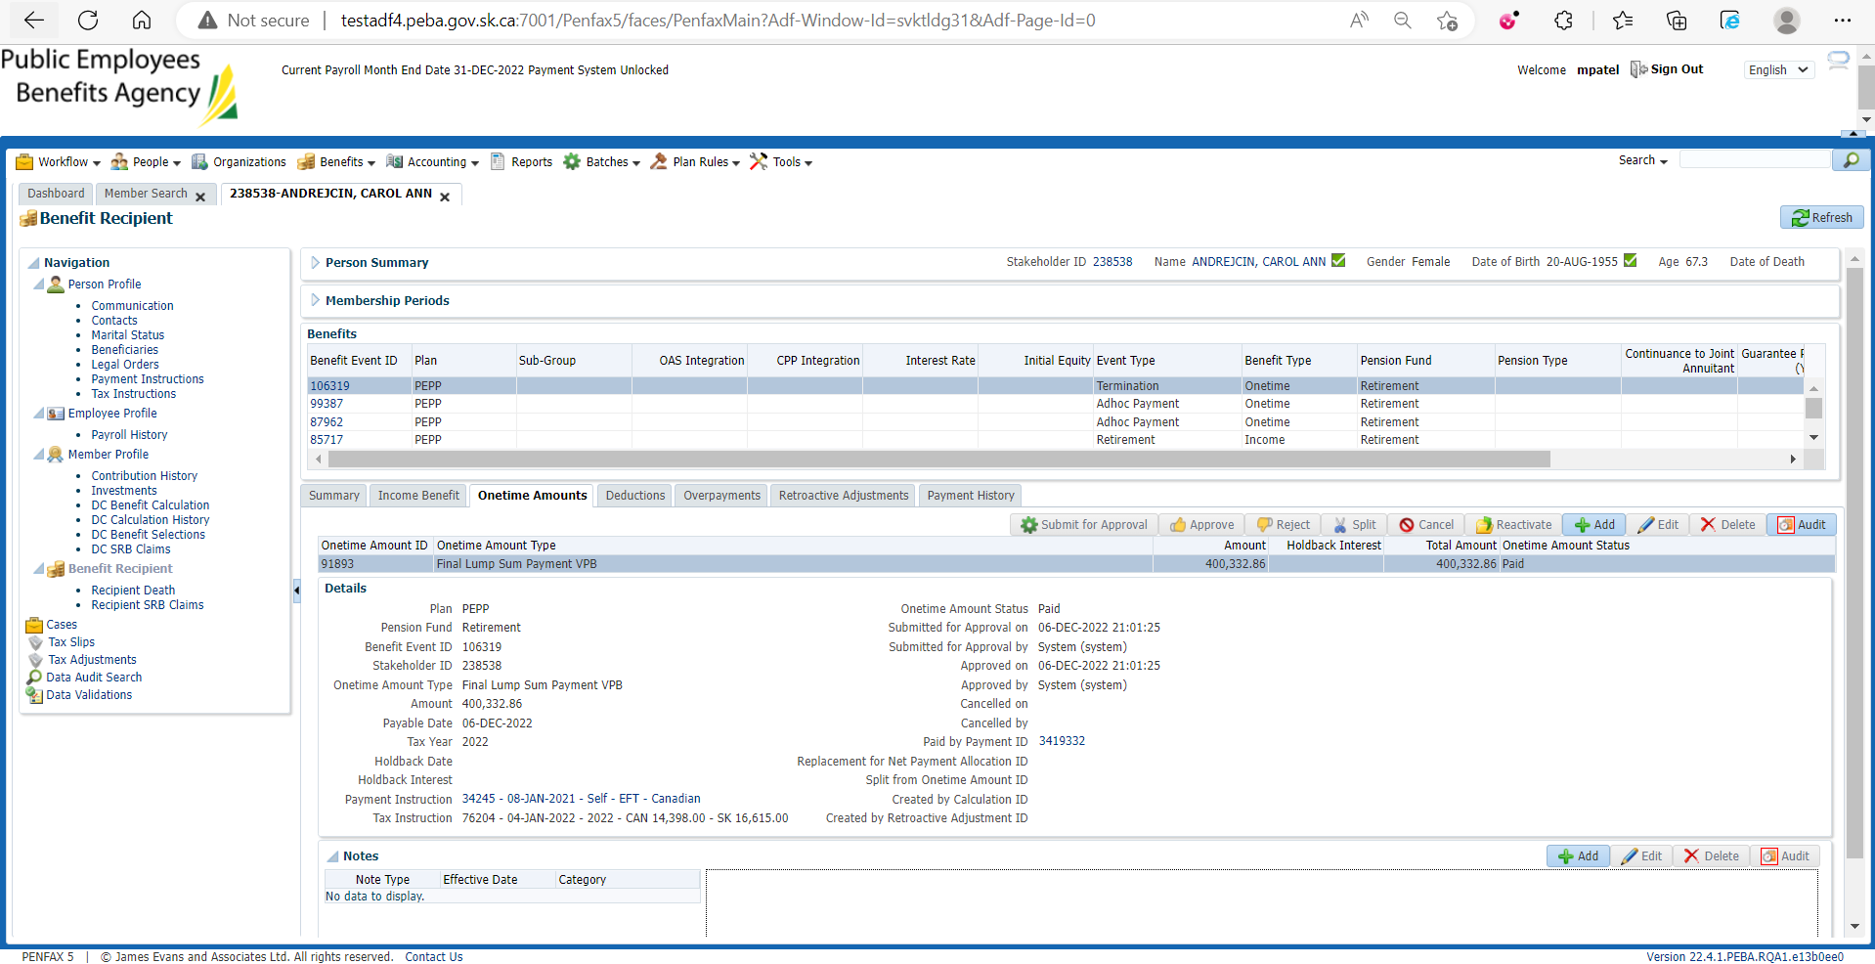

Taxable Income Type-Lumpsum then all previous lumpsums should not be included in Annual Income.

